[JamSabUda INC.]

Chameleoid.

“Always Change”

Version #01

All work Copyright © 2020 by JamSabUda INC.Games.

All rights reserved.

Muhammad Sabeeh, Uday Patel

2022-05-18

**TABLE OF CONTENTS**

**VERSION HISTORY** 3

**I. GAME OVERVIEW** 4

**II. GAME PLAY MECHANICS** 4

**III. CAMERA** 4

**IV. CONTROLS** 4

**V. SAVING AND LOADING** 4

**VI. INTERFACE SKETCH 5**

**VII. MENU AND SCREEN DESCRIPTIONS** 6,7,8

**VIII. GAME WORLD - CREATIVITY!** 9

**IX. LEVELS** 9

**X. GAME PROGRESSION** 9

**XI. CHARACTERS** 9

**XII. ENEMIES** 10

**XIII. ITEMS** 10

**XIV. ABILITIES** 10

**XV. SCORING** 10

**XVI. STORY INDEX** 10

# VERSION HISTORY

2022-05-19 - Muhammad Sabeeh

* Conceptualization of the project

2022-06-10 - Muhammad Sabeeh

* First playable build created, main mechanic and collisions

2022-07-22 - Muhammad Sabeeh

* Beta build, minor bugs ironed out, UI updated and placeholders removed, objective added

# I. GAME OVERVIEW

The goal of the game is to get your player to the end of each level and have the best time recorded. The game will end when the player reaches the final level

# II. GAME PLAY MECHANICS

The main gameplay mechanic of the game is only being able to interact with objects throughout the game world/levels that are the same colour as the player. The colour of the player can be changed by picking up different coloured shapes spread around the map. For example, if the player and the ground are both red then the player can walk on the ground, otherwise they will fall through.

# III. CAMERA

The game has a third-person view. Similar to other famous platformers like Super Mario Bros. and Celeste. The camera is a buffered following perspective to make the game feel more smooth and responsive

# IV. CONTROLS

Movement:

* The player can only move using WASD or arrow keys
* The player can jump using the spacebar

# V. SAVING AND LOADING

The game will feature level some saving. Meaning that the players time will be recorded locally as a sort of personal best times record sheet. The game also features variable saving using static variables, mainly for the timer

# VI. INTERFACE SKETCH

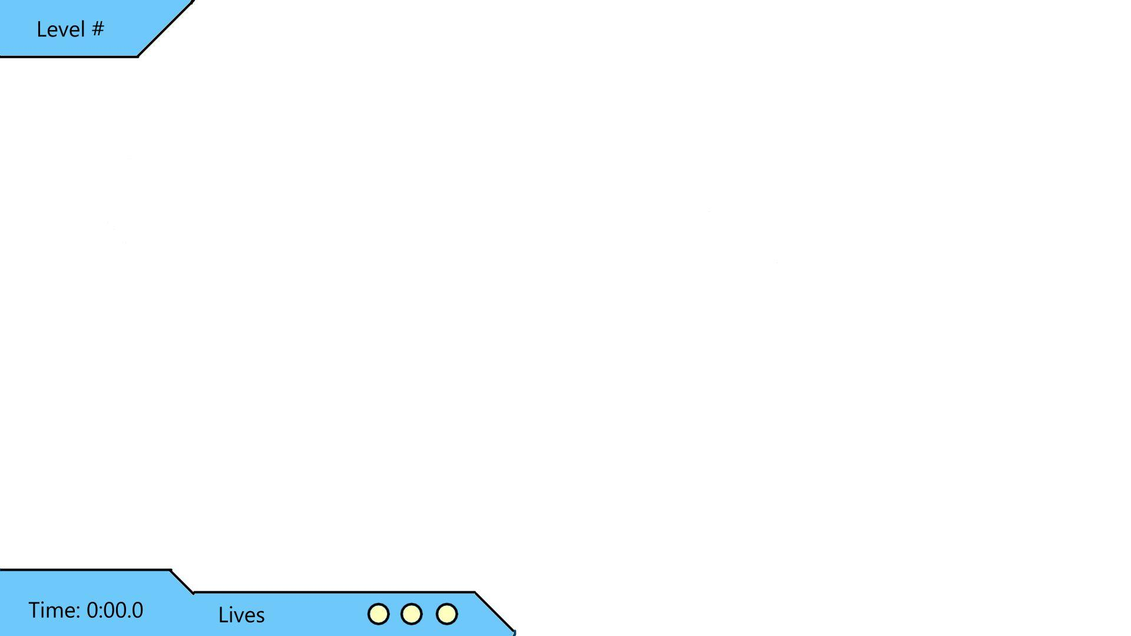

# VII. MENU AND SCREEN DESCRIPTIONS

Menus:

* Main menu

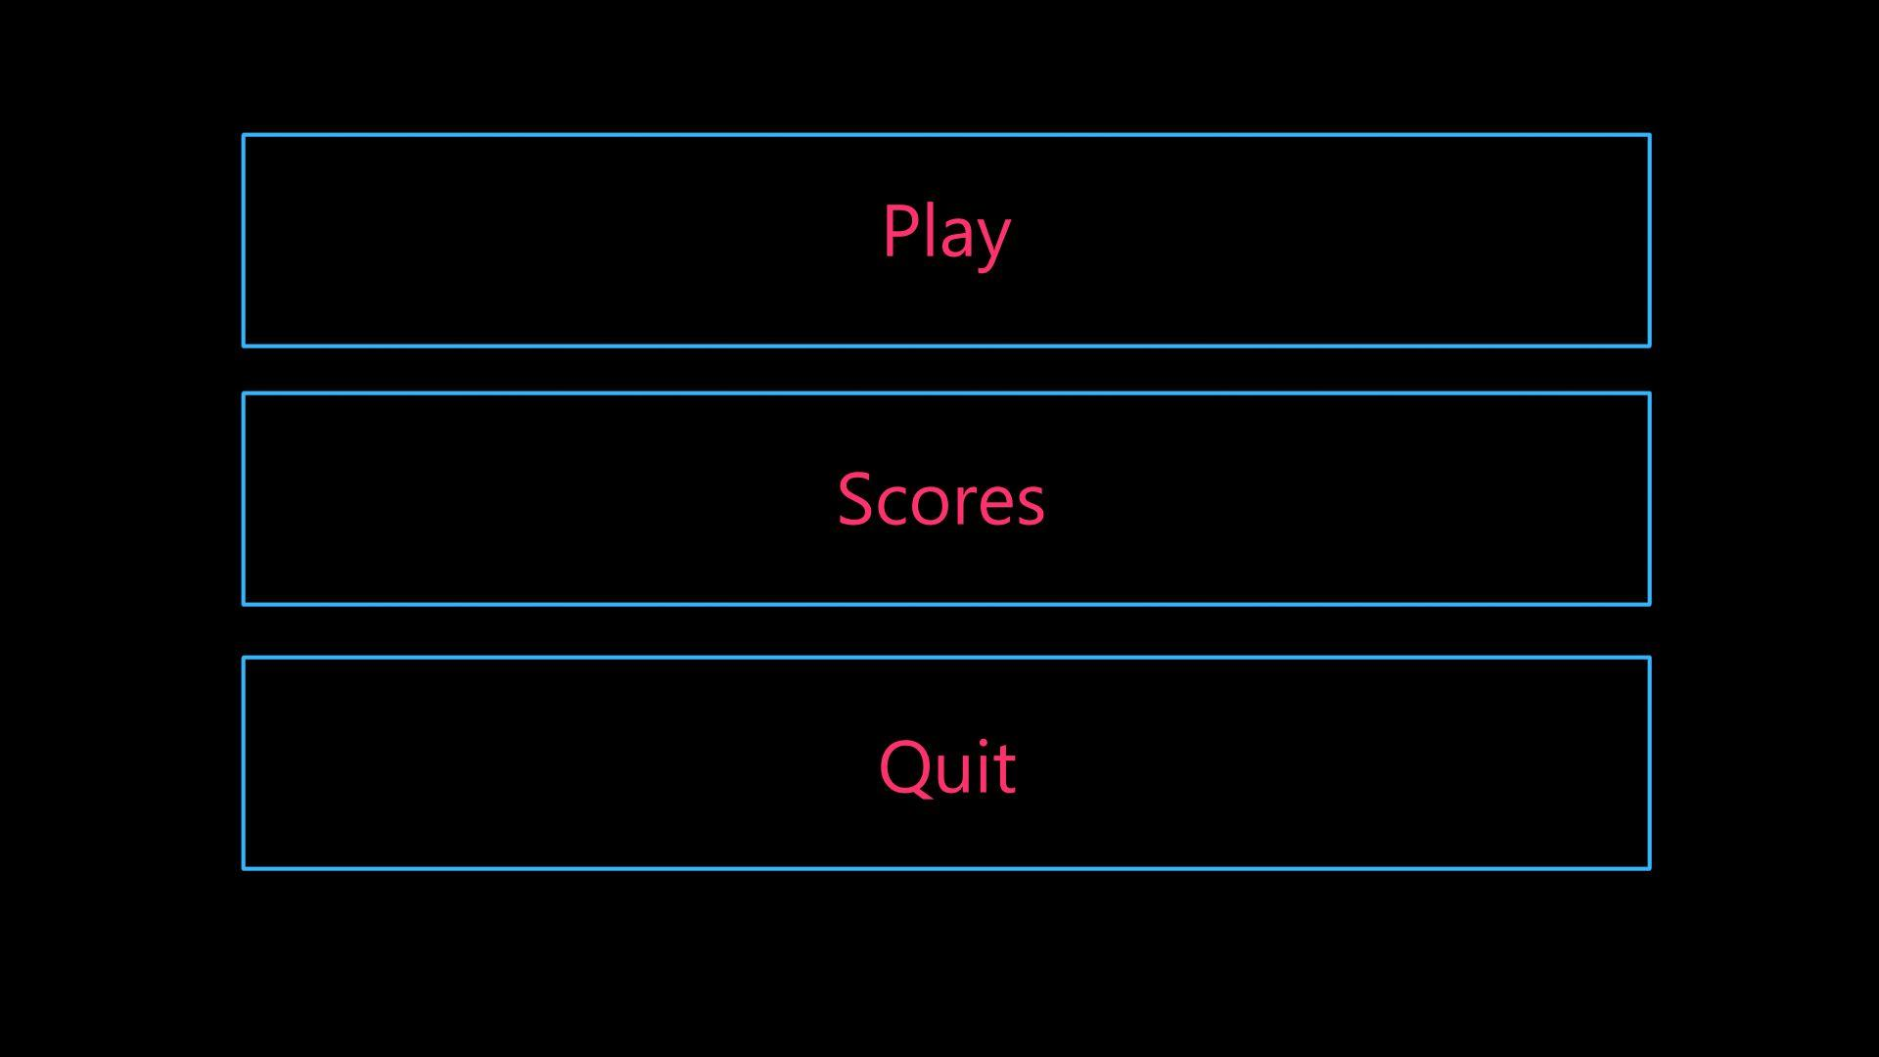

* + Play
  + Quit
  + Highscores
* Death Screen

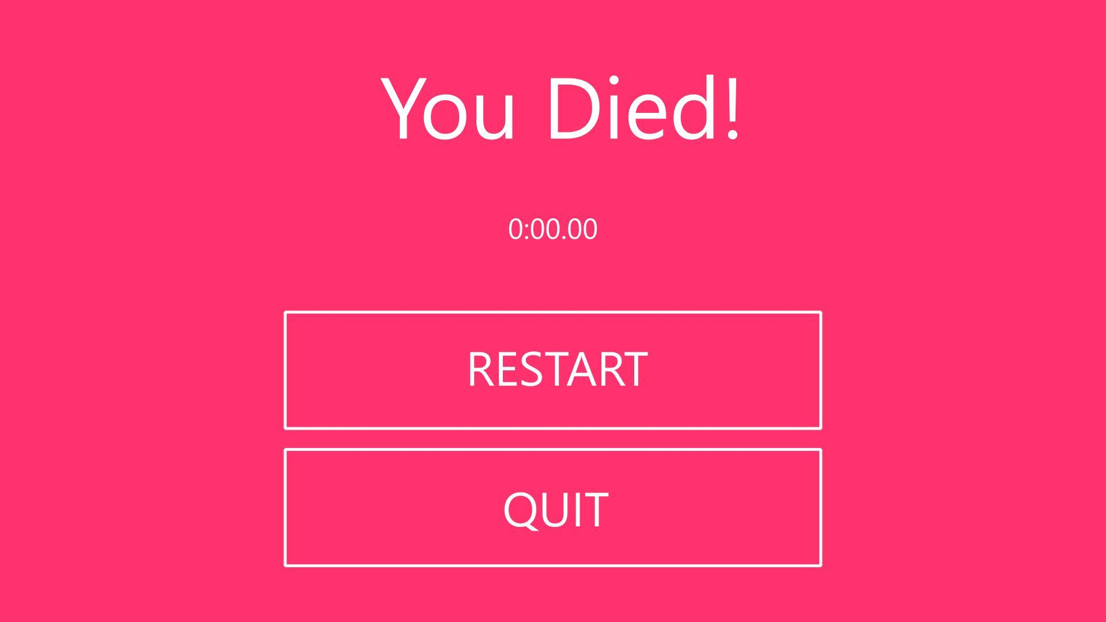

* + Retry
  + Timer
  + Quit
* Win Screen

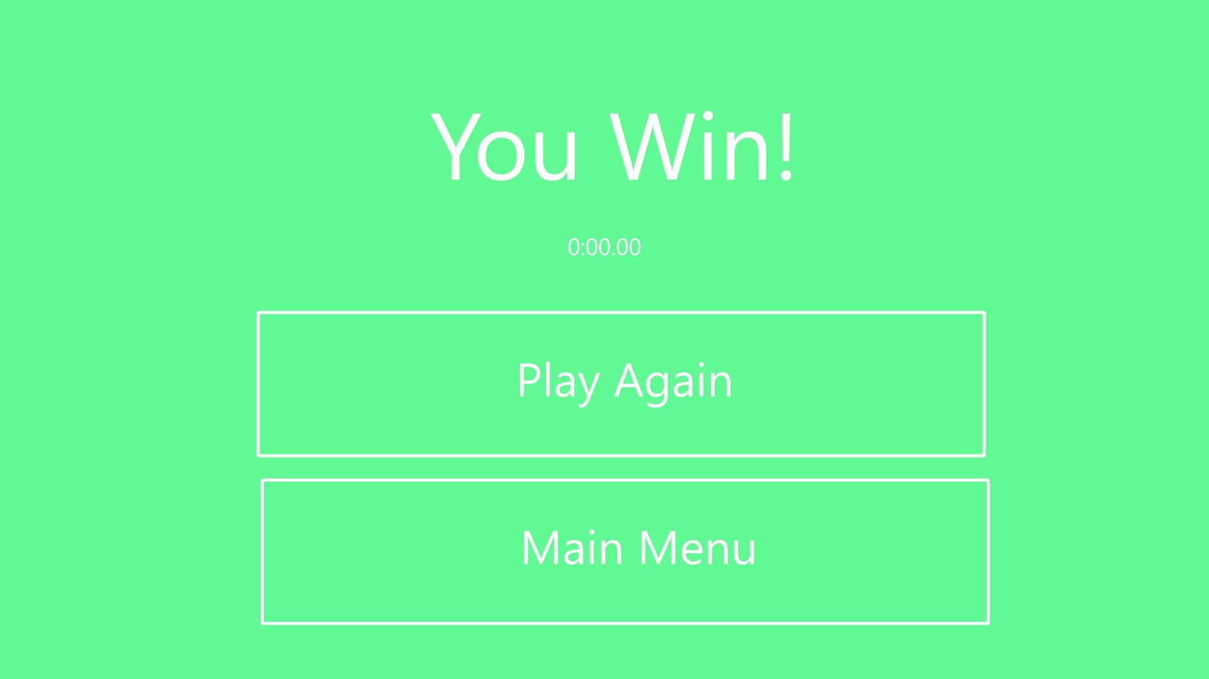

* + Play Again
  + Main Menu
  + Your Time

# VIII. GAME WORLD - CREATIVITY!

The game will feature different colour palettes for each level, although it will be created with simple shapes such as rectangles, triangles and circles, the colour palette will bring variety to each level in order to remove monotony.

# IX. LEVELS

The game will feature simple platformer levels with focus on creative thinking, reaction times, and simple coordination. Each level will feature environmental hazards such as lasers or spikes of the same colours to prevent the player from progressing. Every level will include collectibles in order to open the gate at the end.

Level 1 - Simple tutorial explaining the games mechanics

Level 2 - To somewhat increase level difficulty, introduces basic environmental hazards, such as spikes and moving indestructible objects

Level 3 - Themed level which adds moving and floating platforms

# X. GAME PROGRESSION

The user progresses through each level by reaching the end of the level and entering a gate which will transport them to the next level. The difficulty progression is very tame, as the user beats more levels, the levels begin to get harder and harder.

# XI. CHARACTERS

Main Character - Cube which starts off white at each level and changes colours whenever the player touches a colour-changer

# XII. ENEMIES

AI - indestructible moving environment hazards that move on a predetermined path, can be any shape and colour depending on level design

# XIII. ITEMS

Colour Changers - objects placed around each level to allow the player to change colours

# XIV. ABILITIES

Colour Changing - The main mechanic is also the only ability of the player, being able to change colours via interaction with colour changers.

# XV. SCORING

The scoring system is a timer which displays how long it took the player to beat each level, and their overall time to encourage the player to beat their time each time. It will also include a developer time to give an added challenge.

# XVI. STORY INDEX

The player is a cube which has woken up to find himself in a prison without knowing why they are there and who put them there, all they know is that they must escape to the prison.

# XVII. UPDATES

* WebGL collision/compression issue fix
* Movement tweaking (to make game feel more smooth)
* Add background props for story\
* Iron out any gameplay bugs